Coincident Collinear Segments
# Source: AI Source: Provided by: [Data Path: Persons Table -> ID Column: 1, Name_En Column: Motasem Essam] -> From: [ChatGPT] on [7/25/2026]
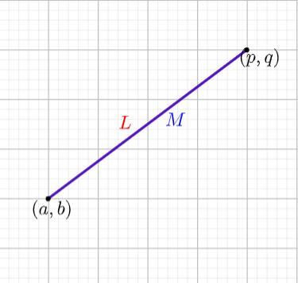
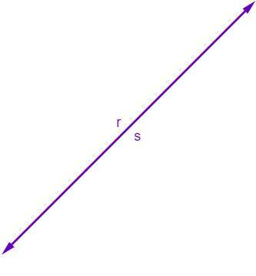
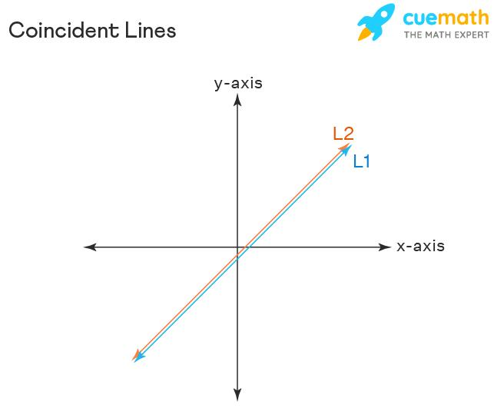

Definition
# Source: AI Source: Provided by: [Data Path: Persons Table -> ID Column: 1, Name_En Column: Motasem Essam] -> From: [ChatGPT] on [7/25/2026]
Coincident Collinear Segments are two or more line segments that lie on the same supporting straight line and occupy exactly the same set of points.
For two segments $\overset{‾}{AB}$and $\overset{‾}{CD}$, they are coincident when:
$$\overset{‾}{AB}⊆l \\ \overset{‾}{CD}⊆l$$
and
$$\boxed{\overset{‾}{AB}=\overset{‾}{CD}}$$
Therefore, every point belonging to one segment also belongs to the other.
Simple Example
A ●────────────────● B
C ●────────────────● D
The two segments have the same position, length, direction, and endpoints as geometric sets.
Thus:
$$\overset{‾}{AB}=\overset{‾}{CD}$$

Purpose
# Source: AI Source: Provided by: [Data Path: Persons Table -> ID Column: 1, Name_En Column: Motasem Essam] -> From: [ChatGPT] on [7/25/2026]
Coincident collinear segments describe the complete positional agreement of two segments.
They are useful for:
- Identifying identical geometric segments
- Coordinate geometry
- Geometric constructions
- CAD and technical drawings
- Computational geometry
- Detecting duplicate geometric objects
- Establishing equality between segments

Fundamental Conditions
# Source: AI Source: Provided by: [Data Path: Persons Table -> ID Column: 1, Name_En Column: Motasem Essam] -> From: [ChatGPT] on [7/25/2026]
Two segments are coincident when all of the following conditions are satisfied.
1. Same Supporting Line
Both segments lie on the same straight line:
$$A,B,C,D∈l$$
2. Same Extent
They cover exactly the same portion of the line.
3. Same Endpoints as a Geometric Set
The endpoints may have different names, but the locations must be identical:
$$\left\{A , B\right\}=\left\{C , D\right\}$$
For example:
$$A=C, B=D$$
or the endpoints may be reversed:
$$A=D, B=C$$
4. Complete Intersection
Their intersection is the entire segment:
$$\boxed{\overset{‾}{AB}∩\overset{‾}{CD}=\overset{‾}{AB}=\overset{‾}{CD}}$$

Example 1: Same Endpoints
# Source: AI Source: Provided by: [Data Path: Persons Table -> ID Column: 1, Name_En Column: Motasem Essam] -> From: [ChatGPT] on [7/25/2026]
Suppose:
$$A=\left(1 , 4\right), B=\left(9 , 4\right)$$
and:
$$C=\left(1 , 4\right), D=\left(9 , 4\right)$$
Then:
$$A=C$$
and
$$B=D$$
Therefore:
$$\boxed{\overset{‾}{AB}=\overset{‾}{CD}}$$
The segments are coincident.

Example 2: Reversed Endpoints
# Source: AI Source: Provided by: [Data Path: Persons Table -> ID Column: 1, Name_En Column: Motasem Essam] -> From: [ChatGPT] on [7/25/2026]
Consider:
$$A=\left(1 , 4\right), B=\left(9 , 4\right)$$
and:
$$C=\left(9 , 4\right), D=\left(1 , 4\right)$$
Although the endpoint names are reversed:
$$A=D$$
and
$$B=C$$
the two segments still represent exactly the same set of points.
Therefore:
$$\boxed{\overset{‾}{AB}=\overset{‾}{CD}}$$
and they are coincident.

Example 3: Number-Line Representation
# Source: AI Source: Provided by: [Data Path: Persons Table -> ID Column: 1, Name_En Column: Motasem Essam] -> From: [ChatGPT] on [7/25/2026]
Consider:
$$\overset{‾}{AB}=\left[2 , 8\right]$$
and
$$\overset{‾}{CD}=\left[2 , 8\right]$$
Then:
$$\overset{‾}{AB}∩\overset{‾}{CD}=\left[2 , 8\right]$$
and:
$$\boxed{\overset{‾}{AB}=\overset{‾}{CD}}$$
The overlap extends across the entire length of both segments.

Coincident Segments vs. Overlapping Segments
# Source: AI Source: Provided by: [Data Path: Persons Table -> ID Column: 1, Name_En Column: Motasem Essam] -> From: [ChatGPT] on [7/25/2026]
This is the most important distinction.
Overlapping
Two segments share part of their length.
Example:
$$\left[1 , 8\right]∩\left[5 , 12\right]=\left[5 , 8\right]$$
Only part is common.
Coincident
Two segments share all of their length.
Example:
$$\left[1 , 8\right]∩\left[1 , 8\right]=\left[1 , 8\right]$$
The entire segment is common.
Therefore:
Coincident segments are completely overlapping, whereas ordinary overlapping segments need only share a positive-length portion.

Comparison with Other Segment Relationships
# Source: AI Source: Provided by: [Data Path: Persons Table -> ID Column: 1, Name_En Column: Motasem Essam] -> From: [ChatGPT] on [7/25/2026]
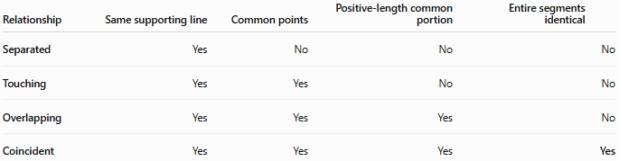
Relationship | Same supporting line | Common points | Positive-length common portion | Entire segments identical
Separated | Yes | No | No | No
Touching | Yes | Yes | No | No
Overlapping | Yes | Yes | Yes | No
Coincident | Yes | Yes | Yes | Yes
The key condition for coincidence is:
$$\boxed{S_{1}=S_{2}}$$
rather than merely:
$$S_{1}∩S_{2}≠∅$$

Mathematical Characterization
# Source: AI Source: Provided by: [Data Path: Persons Table -> ID Column: 1, Name_En Column: Motasem Essam] -> From: [ChatGPT] on [7/25/2026]
Let:
$$S_{1}=\overset{‾}{AB}$$
and
$$S_{2}=\overset{‾}{CD}$$
The segments are coincident if:
$$\boxed{S_{1}=S_{2}}$$
Equivalently:
$$S_{1}⊆S_{2}$$
and
$$S_{2}⊆S_{1}$$
Therefore:
$$\boxed{S_{1}⊆S_{2} \text{and} S_{2}⊆S_{1}}$$
implies:
$$S_{1}=S_{2}$$

Interval Representation
# Source: AI Source: Provided by: [Data Path: Persons Table -> ID Column: 1, Name_En Column: Motasem Essam] -> From: [ChatGPT] on [7/25/2026]
For two segments represented as intervals:
$$S_{1}=\left[a , b\right] \\ S_{2}=\left[c , d\right]$$
with:
$$a<b, c<d$$
they are coincident exactly when:
$$\boxed{a=c \text{and} b=d}$$
If the endpoints are represented without assuming an ordering, the condition can be written as:
$$\boxed{\left\{a , b\right\}=\left\{c , d\right\}}$$
This allows either orientation.

Length Property
# Source: AI Source: Provided by: [Data Path: Persons Table -> ID Column: 1, Name_En Column: Motasem Essam] -> From: [ChatGPT] on [7/25/2026]
Coincident segments necessarily have equal lengths:
$$\boxed{AB=CD}$$
For example, if:
$$AB=7$$
then:
$$CD=7$$
However, equal length alone does not prove coincidence.
For example:
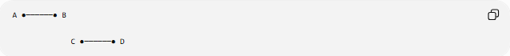
A ●──────● B

C ●──────● D
These segments can have:
$$AB=CD$$
while being separated and therefore not coincident.

Direction and Orientation
# Source: AI Source: Provided by: [Data Path: Persons Table -> ID Column: 1, Name_En Column: Motasem Essam] -> From: [ChatGPT] on [7/25/2026]
Coincident segments lie on the same supporting line.
Their geometric direction is therefore the same line, although their ordered endpoint directions can be the same or opposite.
For example:
$$\vec{AB}$$
and
$$\vec{CD}$$
may point in the same direction, while:
$$\vec{AB}$$
and
$$\vec{DC}$$
point in opposite directions.
This does not change the fact that the underlying segments are coincident.
A line segment itself has no intrinsic orientation unless an ordered pair of endpoints is being used.

Important Properties
# Source: AI Source: Provided by: [Data Path: Persons Table -> ID Column: 1, Name_En Column: Motasem Essam] -> From: [ChatGPT] on [7/25/2026]
- Coincident segments lie on the same supporting line.
- They contain exactly the same points.
- Their intersection is the entire segment:
$$S_{1}∩S_{2}=S_{1}=S_{2}$$
- They have equal lengths:
$$∣S_{1}∣=∣S_{2}∣$$
- They have the same endpoints as geometric locations.
- Endpoint names may be different.
- Endpoint order may be reversed.
- Coincidence is symmetric:
$$S_{1}=S_{2} ⟺ S_{2}=S_{1}$$
- Coincident segments are completely overlapping.
- Equal length by itself does not imply coincidence.

Coincident Collinear Segments and Equality
# Source: AI Source: Provided by: [Data Path: Persons Table -> ID Column: 1, Name_En Column: Motasem Essam] -> From: [ChatGPT] on [7/25/2026]
Coincidence is closely related to geometric equality.
If:
$$\overset{‾}{AB}=\overset{‾}{CD}$$
then the two segments are the same geometric object, even if they are described using different endpoint names.
For example:
$$A=\left(0 , 0\right), B=\left(6 , 0\right)$$
and:
$$C=\left(6 , 0\right), D=\left(0 , 0\right)$$
represent the same segment.
Thus:
$$\boxed{\overset{‾}{AB}=\overset{‾}{CD}}$$

Coincident vs. Touching
# Source: AI Source: Provided by: [Data Path: Persons Table -> ID Column: 1, Name_En Column: Motasem Essam] -> From: [ChatGPT] on [7/25/2026]
Touching
Two segments meet at a boundary point but do not share a positive-length portion:
$$S_{1}∩S_{2}=\left\{P\right\}$$
Therefore:
$$length⁡\left(S_{1}∩S_{2}\right)=0$$
Coincident
They share their entire extent:
$$S_{1}∩S_{2}=S_{1}=S_{2}$$
Therefore:
$$length⁡\left(S_{1}∩S_{2}\right)>0$$
and the overlap is complete.

Coincident vs. Separated
# Source: AI Source: Provided by: [Data Path: Persons Table -> ID Column: 1, Name_En Column: Motasem Essam] -> From: [ChatGPT] on [7/25/2026]
Separated segments have:
$$S_{1}∩S_{2}=∅$$
Coincident segments have:
$$S_{1}∩S_{2}=S_{1}=S_{2}$$
They therefore represent opposite extremes of positional relationship along the same supporting line.

Real-World Applications
# Source: AI Source: Provided by: [Data Path: Persons Table -> ID Column: 1, Name_En Column: Motasem Essam] -> From: [ChatGPT] on [7/25/2026]
CAD and Computer Graphics
Two independently created edges may represent exactly the same geometric segment. Detecting coincidence prevents duplicate geometry.
Engineering Drawings
Different construction elements may share exactly the same boundary segment.
Geographic Information Systems
Two mapped features may contain the same boundary segment.
Geometry Software
Coincidence detection is used to determine whether two geometric objects represent the same location.
Construction
Multiple geometric descriptions may refer to the same physical edge or boundary.

Key Points
# Source: AI Source: Provided by: [Data Path: Persons Table -> ID Column: 1, Name_En Column: Motasem Essam] -> From: [ChatGPT] on [7/25/2026]
- Coincident Collinear Segments lie on the same supporting line.
- They contain exactly the same points.
- Their entire lengths coincide.
- Their intersection equals both segments:
$$\boxed{S_{1}∩S_{2}=S_{1}=S_{2}}$$
- They have equal lengths.
- Their endpoint names can differ.
- Their endpoint order can be reversed.
- Equal length alone does not establish coincidence.
- Coincidence represents complete overlap, whereas ordinary overlapping represents only partial or non-complete shared extent.

Conclusion
# Source: AI Source: Provided by: [Data Path: Persons Table -> ID Column: 1, Name_En Column: Motasem Essam] -> From: [ChatGPT] on [7/25/2026]
Coincident Collinear Segments are line segments that lie on the same straight line and occupy exactly the same geometric location. They are the complete-overlap case of segment collinearity and can be characterized by:
$$\boxed{\overset{‾}{AB}=\overset{‾}{CD}}$$
Thus, the essential distinction is:
Separated → no common points → Touching → one-point contact → Overlapping → positive-length common portion → Coincident → entire segment common.

